create table Customer(Cust# varchar2(10) not null primary key,Cname varchar2(10) not null,City varchar2(10))

create table Orders(Ord# varchar2(10) not null primary key,Odate date,Cust# varchar2(10) references Customer(Cust#),Ord_Amt int)

create table Item(Item# varchar2(10) not null primary key,Unit_Price int)

create table Order_Item(Ord# varchar2(10) references Orders(Ord#),Item# varchar2(10) references Item(Item#),Qty int)

create table Warehouse(Warehouse# varchar2(10) not null primary key,City varchar2(20))

create table Shipment(Ord# varchar2(10) references Orders(Ord#),Warehouse# varchar2(10) references Warehouse(Warehouse#),Ship_Date date)

SCHEMAS:

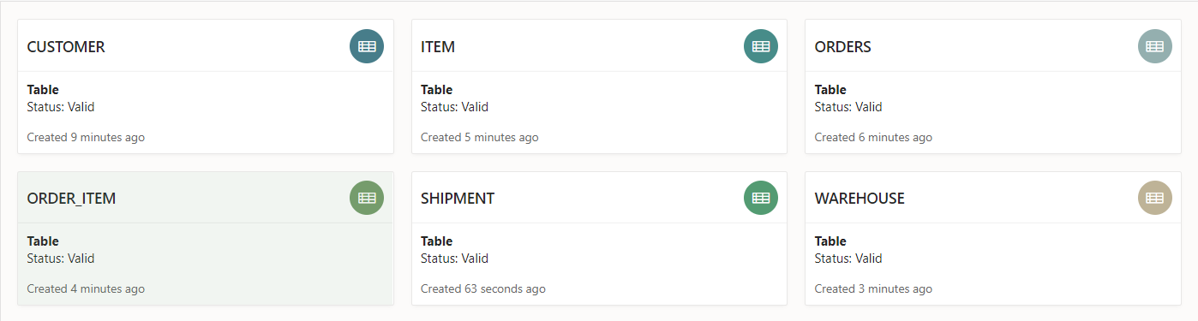

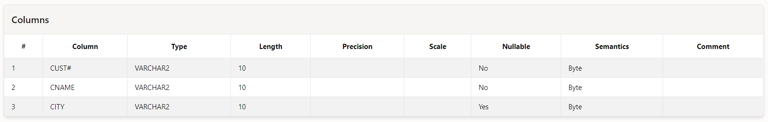

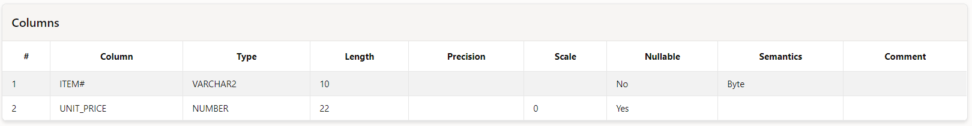

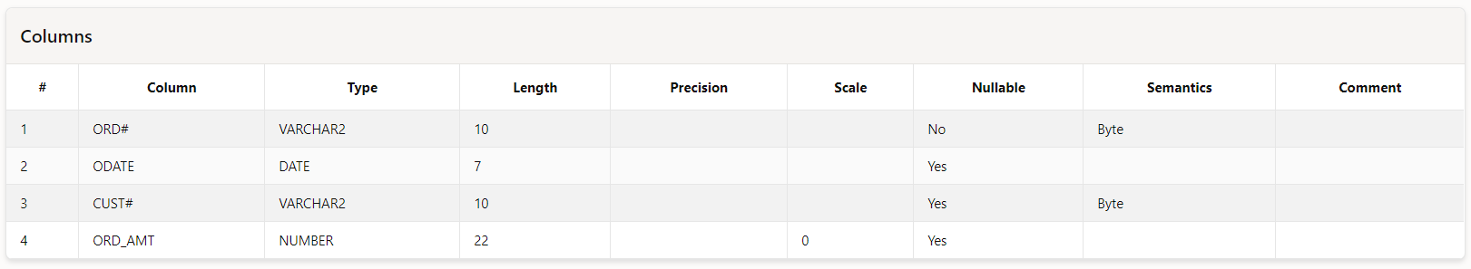

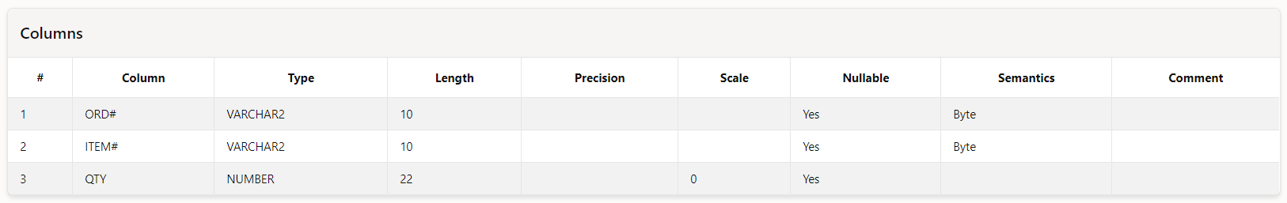

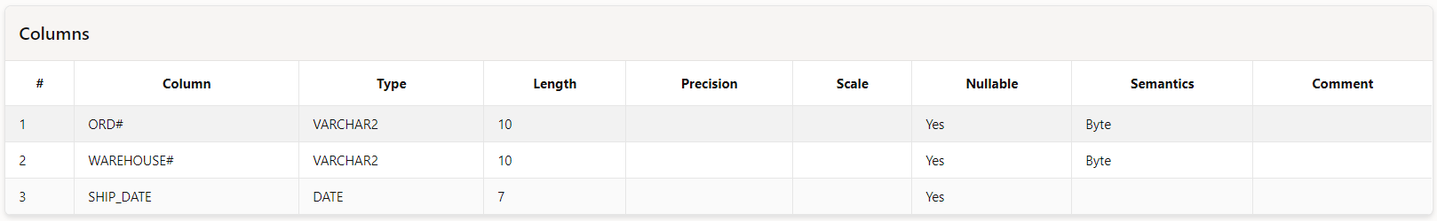

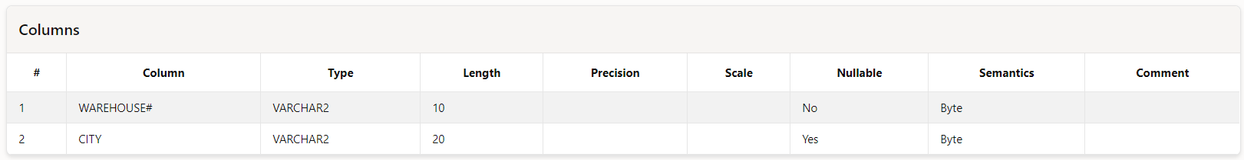

insert into Customer values('C1','John','ABC')

insert into Orders values('2',to_date('10/07/2020','DD/MM/YYYY'),'C1',3000)

insert into Item values('I4',300)

insert into Order_Item values('2','I4',10)

insert into Warehouse values('W1','Chennai')

insert into Shipment values('2','W1',to_date('10/08/2020','DD/MM/YYYY'))

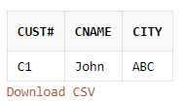

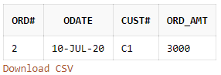

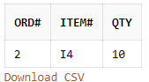

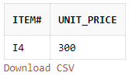

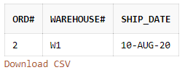

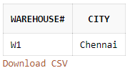

3) Select * from Customer;



4) select City from Warehouse where (wherehouse# = ‘W1’);

5)Select * from Customer where Cname=’John’;

6)

7)Select * from Item where Item#=’I2’;